57.0.0.9/37.0.0.9
- Bugs fix:
  - 806 - Shutdown wizard doesn't close machine OHDB power
  - 936 - "Please Replace" message
  - 1161 - Change resin order to be near each other instead on top
  - 1242 - CANCEL\NEXT button doesn't working
  - 1243 - UV Power test results
  - 1258 - Remove tray area fro General Device window
  - 1267 - Merge the 'UV Power Test Results' to one general window
  - 1278 - Block hitting the model
  - 1310 - Change the led background in actuators & sensors +motors
  - 1341 - Results screen
  - 1362 - Incorrect current mode
  - 1364 - Wiper cleaning wizard
  - 1368 - Problem with clean heads wizard
  - 1372 - The Cancel\Done buttons doesn't working well
  - 1375 - Add to log file :Roller tilt wizard started\ended
  - 1398 - Change models order in 'Resin replacement mode' page
  - 1407,1411 - Problem with printing position
  - 1413 - RR WIZARD - SECOND WASH
  - 1425,1426 - After vacuum error event - Stopping should be immediate
  - 1438 - Change the 'M' on the cartridges in main preview screen
  - 1440 - Wizard needs to close when selecting the 'NO' answer
  - 1441 - Remove unneeded question ( the Mode selecting question)
  - 1464,1465 - Lamps stay ON at the end
  - 1473 - Incorrect heads heating and display
  - 1494 - Wrong calibrated value
  - 1501,1506 - Double Short RR
- 'Head Alignment.cfg' changes
57.0.0.8/37.0.0.8
- Bug 1278 - Block hitting the model
- Resin Replacement wizard – The following flow implementation
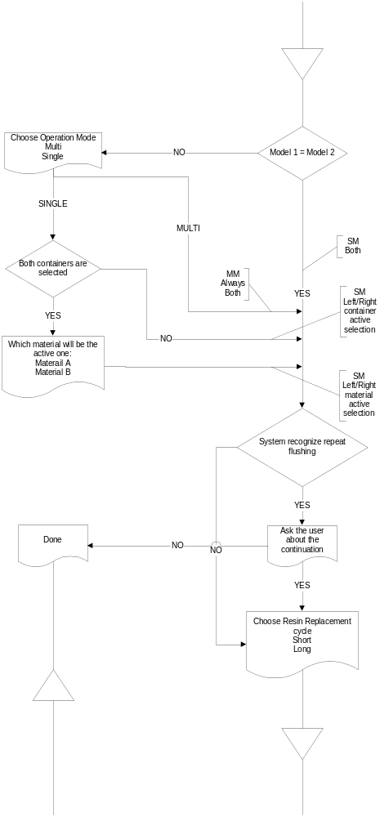
57.0.0.7/37.0.0.7
- Bug 704 - Add "Are U Sure" Q message when pressing Stop in the EM
- UV Calibration wizard
  - Bug 1266 - Power test bug fix
  - Bug 1267 - Merge the 'UV Power Test Results' to one general window
  - Bug 1313 - Home for T axis (when the wizard started)
  - Change each stabilization wait to be 30 sec. (Eduardo request)
  - Add stabilization wait at mode change – 30 sec. (Eduardo request)
  - Strings change:
    - Catridges - Model 1/Model 2
    - Chambers - M0-1, M2-3
    - Maintenance->Wizards - Service Wizards

57.0.0.6/37.0.0.6
- Slice number added to “show incoming slice windows”
- Cartridge error dialog is “Always on top” from now
- 4 Model pumps (instead of 2 model pumps and 3 valves) support
  - Actuators window
  - Resin replacement wizard
  - Head filling wizard
- Name conventions change

57.0.0.5
- Printing DJ Bug was resolved
- Bug 1261 - 'Previous' button
- Bug 1262 - calibration waste container weight

57.0.0.4 - NO
- Wizards side window was removed
- Bumper Calibration new logic
  - Can not be printed with Tango
  - Preferred printing mode is E500
  - If no E500 possible print in DJ mode
- Modes Logic UI and internal changes
- Shutdown Wizard
- Load Cell Wizard
- UV Replacement Wizard
- Fixed Bugs:
  - Bug 1241 - Power test only for right lamp
  - Bug 1082 - RR wizard doesn't open automatically
  - Bug 1152 – with the new scenario
- Parameter changes:
  - UVSensorRightLampOffset+UVSensorLeftLampOffset = UVSensorLampOffsetArray
  - UVSensorRightLampGain+ UVSensorLeftLampGain= UVSensorLampGainArray
  - UVSensorRightLampXPosition+ UVSensorLampXPosition= UVSensorLampXPositionArray
  - UVSensorRightLampYPosition+ UVSensorLampYPosition= UVSensorLampYPositionArray
  - BumperCalibrationPermissive
  - QR_MaterialWeightFactorArray

57.0.0.3 - NO
- New Valves/Pumps logic in “Resin Replacement Wizard”
- Fixed Bugs: (http://bugs.2objet.com/show_bug.cgi?id= XXXX)
  - Bug 1076 - Remove the numbers from the tanks
  - Bug 1085 – Machine type doesn't update after RR wizard
  - Bug 1115 – Mode doesn't update while moving from E500 to DJ –
duplicate (1085)
  - Bug 1116 – Wizard RR
  - Bug 1145 – Add in the log file reference to resins and segments
  - Bug 1150 – Preview resin isn't the default choose in the RR select resin
  - Bug 1152 – Problem when using the 'cancel' button in RR –
duplicate (1085)
  - Add description to RR_TypesArrayPerSegment

57.0.0.2 - NO
- SHR Wizard
- ‘Head Alignment.cfg’ changed
- Fixed Bugs: (http://bugs.2objet.com/show_bug.cgi?id= XXXX)
  - Bug 1027 - "Heads filling" Monitor screen area - required update
  - Bug 1073 - Change wording in the log
  - Bug 1074 - Add titles in the log
  - Bug 1084 - RR wizard - add the word tank/cartridge

57.0.0.1 - OK
- Change mode name back to “~Eden 500 Mix.cfg”
- Add DumpToFile parameter
- UV Calibration wizard

57.0.0.0 - OK

